**Nokia 5110 configuration**

|  |  |
| --- | --- |
| **Raspberry PI GPIO** | **5110 LCD** |
| 18 GPIO 24 | RST |
| 24 SPI_CE0 | CE |
| 16 GPIO 23 | DC |
| 19 SPI_MOSI | DIN |
| 23 SPI_SCLK | CLK |
| 1 VCC 3.3V | VCC |
| 11 GPIO 17 | LIGHT |
| 6 GND | GND |

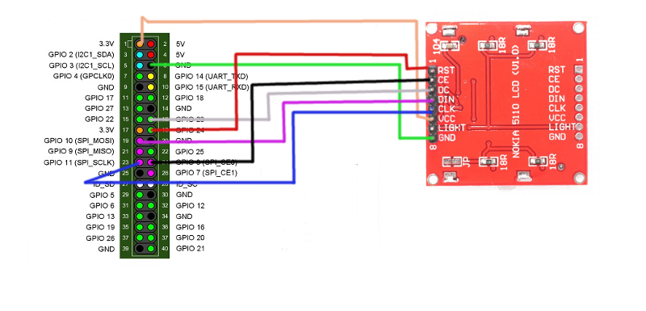

**Install the required software:**

sudo apt-get update  
sudo apt-get install python-pip python-dev build-essential python-imaging

sudo pip install RPi.GPIO

Edit the boot configuration and uncomment or add “dtparam=spi=on”

sudo vim /boot/config.txt

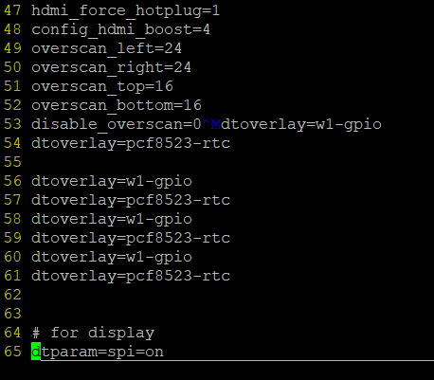

**Reboot the system and verify that the spi module is loaded:**

sudo reboot

lsmod | grep "spi_bcm*"

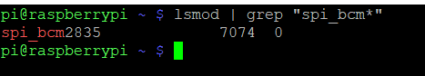

**Clone and install the library for the display:**

git clone https://github.com/adafruit/Adafruit_Nokia_LCD.git  
cd Adafruit_Nokia_LCD  
sudo python setup.py install

**Now you can start the display.py script located at Weatherstation/Python/Display:**

sudo python display.py

Source:

<https://www.algissalys.com/how-to/nokia-5110-lcd-on-raspberry-pi>